|  |  |  |  |  |  |
| --- | --- | --- | --- | --- | --- |
| **Module No:** | 8 | **IU No:** | 1 | **Exercise No.** | 1 |

Learner Name : Agung Yuda Pratama  
Cohort : BDSE-0922-076 / STTB

|  |  |
| --- | --- |
| **Lab Assessment Statement** | **Assignment 1 - Build an API**  **Project Scenario,**  The scope of this assignment is to develop an API for ‘XYZ Cars Pte Ltd’ as a website developer to develop a Used Car Sales portal.  In this assignment, Users will be able to register in the portal using the Registration Page. Users of the portal can search for Cars using Make, Model, Registration & Price Range. Users will be able to view the Car information after searching them. The portal allow users to login, post Car for sale.  These are the steps provided to build an API.   1. Create SpringBoot application [Spring Initializr](https://start.spring.io/). Import the project in your IDE. 2. Create entities for your backend as per the scenario. 3. Create Repositories using JPA repositories. 4. Create service layer to access the data in your API 5. Create controller for your application using REST API 6. Test your API using POSTMAN tool.   **Provide the source code of developed application.**  **Provide screen capture of final result pages for API testing.** |
| **Technical Environment** | -JAVA, JPA, REST API |
| **Guidelines** | - |
| **Duration** | 120 mins |

1. Create SpringBoot application [Spring Initializr](https://start.spring.io/). Import the project into your IDE.

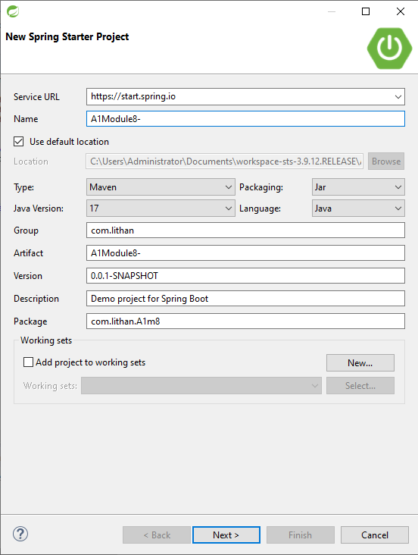Click new and click Spring Starter Project and make it like this.

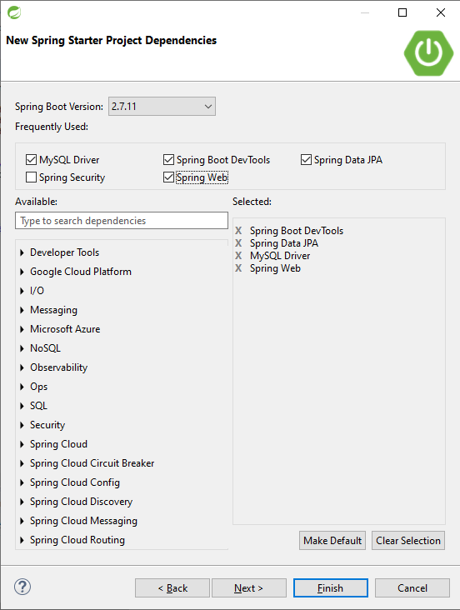

1. Create entities for your backend as per the scenario.

User.java

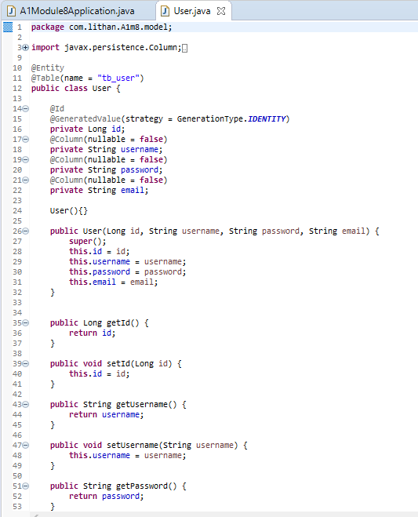

Car.java

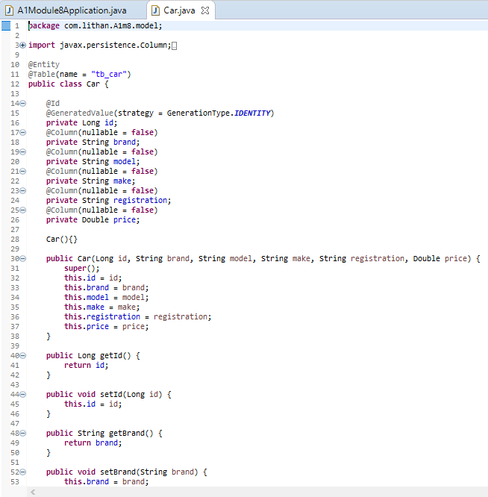

1. Create Repositories using JPA repositories.

CarRepository.java

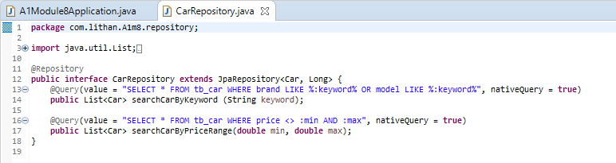

UserRepository.java

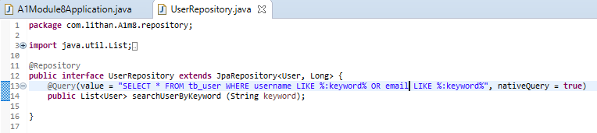

1. Create service layer to access the data in your API

CarService.java

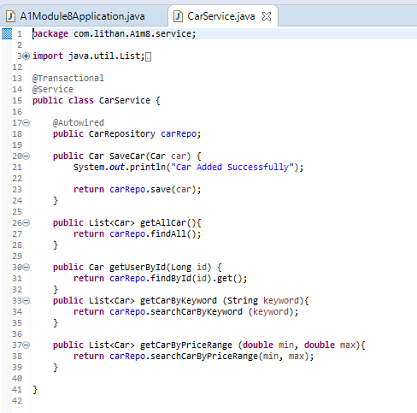

UserService.java

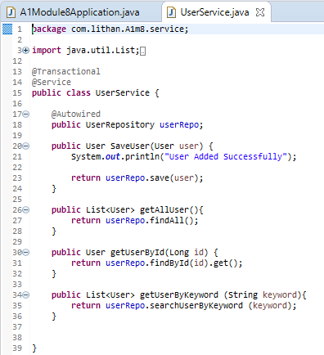

1. Create controller for your application using REST API

CarController.java

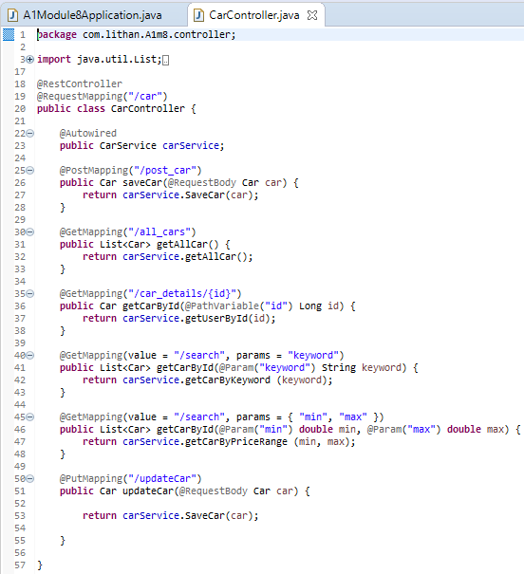

UserController.java

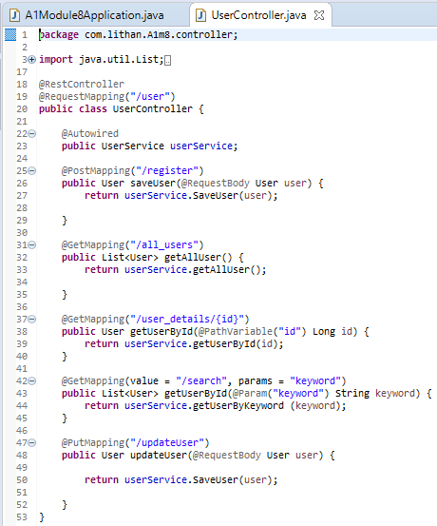

1. Test your API using POSTMAN tool.

|  |
| --- |
| **Register User** |
|  |
| **View All User** |
|  |
| **User Details** |
|  |
| **Search User** |
|  |
| **Update User** |
|  |
| **Post Car** |
|  |
| **View All Car** |
|  |
| **Car Details** |
|  |
| **Search Car** |
|  |
| **Update Car** |
|  |